Employment Information System

The Employee Information System is a system designed to get employees information and display them on a table format.

Main Features For Application

Front-end = Swing

Backend = Database, MyPHPAdmin

Login

Homepage

Login page

The login page consist of a username and password to enter into the homepage. And has a login and a exit button if user wants to enter into the homepage the can press the login button or they can exit to come out of the application A screenshot of a login screen

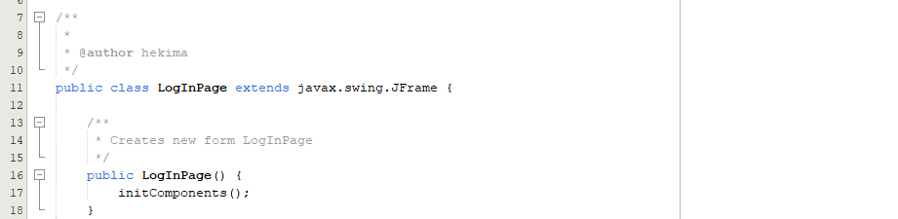

* This part of code is within the login page ,its a constructor method for the Login Page class. In this case, when a user creates a Login Page object, this method will be executed.

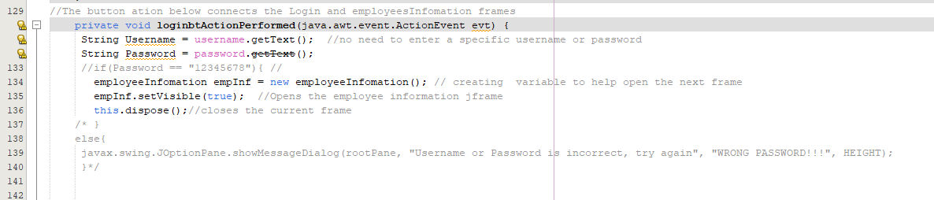

• //The login button also connects the Login and the homage frames . I tried implementing username and password within the log in page, but got some errors as you can see on the screenshot so I commented it out and hence username and password are not compulsory.

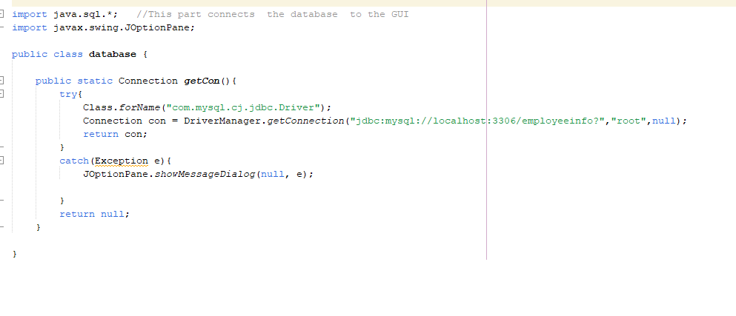

This line of code connects the database to the GUI

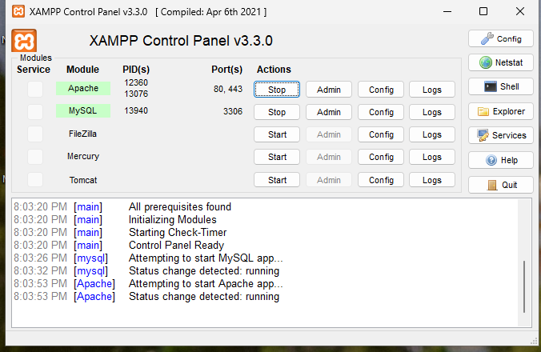

I am using xampp a free, open-source software package that provides a local server environment for development. It includes Apache (a web server), MySQL (a database system), and PHP (a scripting language), making it easy to develop and test my applications on your computer.

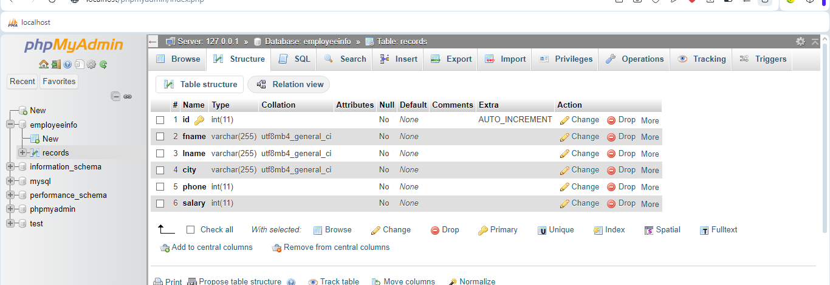

This is the database…

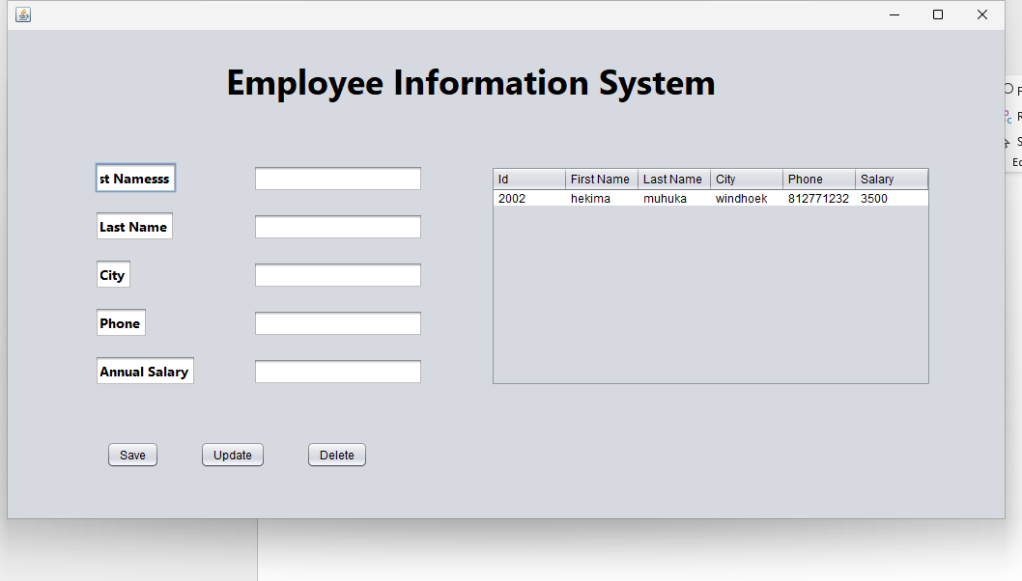

This is the home page …